Ideation Phase
Brainstorm & Idea Prioritization Template

Date | 27 August 2026
Project Name | Employee Raise Issue
Maximum Marks | 4 Marks

Brainstorm & Idea Prioritization Template:
Brainstorming is a collaborative technique used to identify problems, generate possible solutions, and select the most effective approach. For the Employee Raise Issue project, brainstorming helps the team understand the difficulties employees face while reporting salary or appraisal-related concerns. Different ideas are discussed openly, grouped based on their purpose, and prioritized according to their usefulness, feasibility, and impact.
Step-1: Team Gathering, Collaboration and Select the Problem Statement
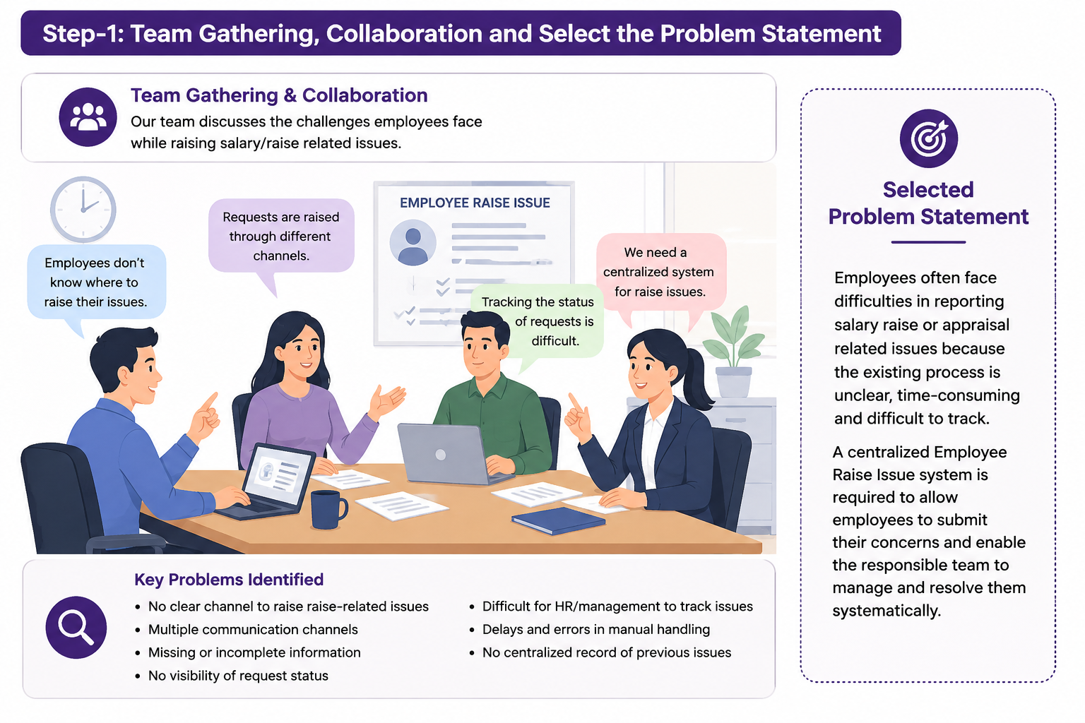

Step-2: Brainstorm, Idea Listing and Grouping
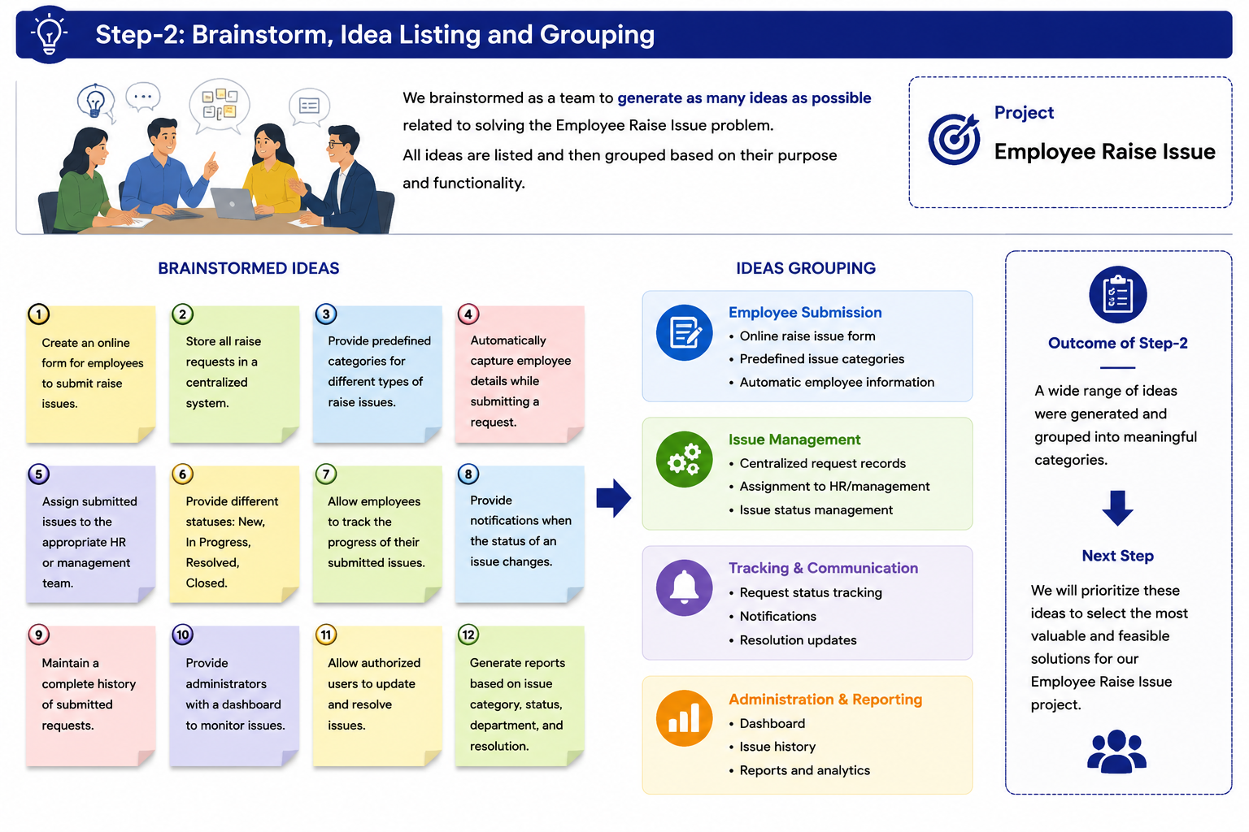

Step-3: Idea Prioritization
